1. Title. Role Playing videogame. (for an Android) “**Dark Battle”,”** **Igor the conqueror”**
2. Goal. To develop a specific game with a name “**Igor the conqueror**” techniques and tools used in the development of interactive media projects. The main objective of the project is to create a 2D RPG computer game that is suitable for all ages and genders.
3. Target audience. My target audience is probably in their mid-20s to mid-30s. Who grew up with a 2D games consoles such as Gameboy, Sega Mega Drive 2, Nintendo etc. who likes music from Arcade games machines. By this age my target person would have a family or start one. Might have a full-time job/student. This game will be perfect for person who likes Single-dimensional (SD) games with a little of story that easy to follow. Some experience in gaming is preferable. My target audience is not necessarily cares about graphics.What situation will it be used in? Whenever client has a free time that he would like to spend on a game.
4. Objectives. -Main goal of a RPG game is Entertainment. -Also, game will train brain and memory. -Pass the time in a queue for example
5. Content. Classic RPG game with build in menu (with an opportunity for an Android in future), bosses, battles, dialogs, money, shops.

Player spawn at main map with shops and different exit for a exploring the different maps, where adventure await. Game will include bosses, shopping for a weapons etc.

**How to control**: Four keyboard keys that are used to interact with video games in Arrow keys or a controller. W and S control forward and backward movement, while A and D are left and right.

Arrows also can be used by default.

**Language**: English

Game is 2D and pixelated.

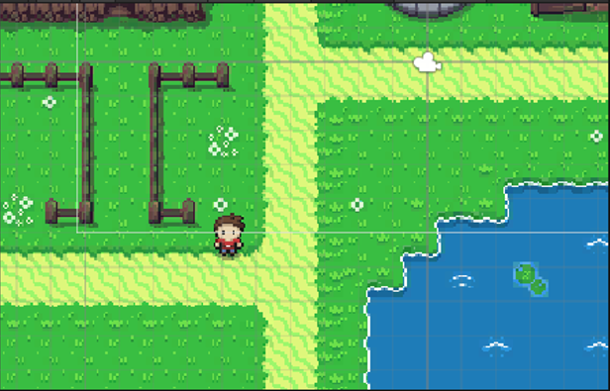

1. Content treatment i.e. “look and feel”. I have not done it yet

Need to explain everything

1. Unity – game developing tool (software), Visual Studio - text editor, music editor, photoshop(optional). C# - programming language. For Android platform.
2. Media Assets Everything needs to be done according to requirements and standards. Audio, pictures, game-plan.

**Why I choose and what I choose**

**Image:** For my project RPG Game PNG format was chosen as a format that support alpha transparency which is extremely important for a 2D Game Developing. Another advantage of this format is lossless compression. Most software supports writing it, most libraries support reading it, it's a standard popular format. Besides PNG another format might be very useful for creating a sprites and maps is PSD, as photoshop is very useful tool for game developing.

PNG is a best choice for UNITY platform as a no matter what you use Unity will Convert them to DDS DXT5(not always DXT5) when you build or when you run the game.

1. Ethical/legal issues: Idea must be unique, preferably licensed. With no copyright problems. All pictures, video, images, animation, and sounds will be from an open sources, which means I am not going to violate act of privacy No information will be collected from a clients/(customers) player. Game will be free to use.
2. Total time estimated:150 hours at least.

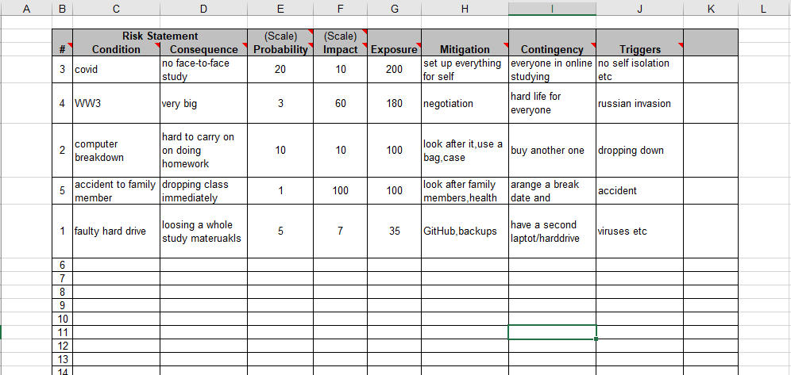

1. **Navigation Map**

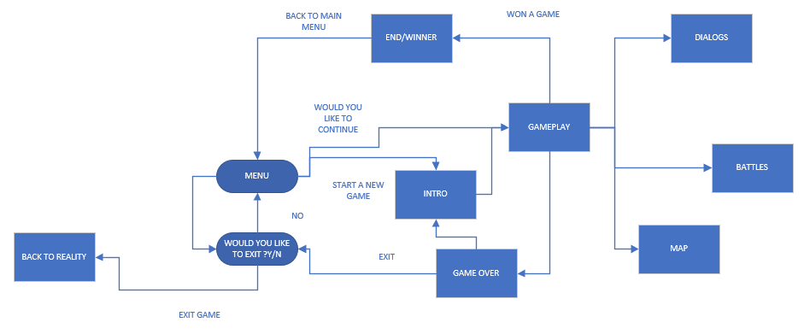

1. **Low-fidelity prototype.**

For my low- fidelity prototype I have chosen a storyboarding cards. With the help of specially handmade cards, I will be able to illustrate the scheme and plot of the game for my client. In addition, the client will be 100% involved, as he will follow my commands by moving the figure around the cards and performing basic commands, such as draw a sword or start a dialogue.

**14.Implications and Ethics**

**Implication of a screen time**

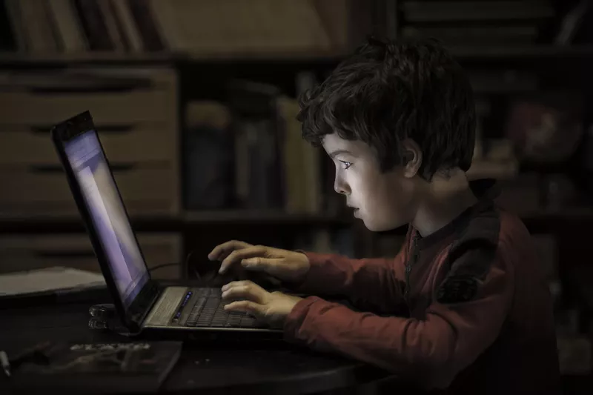

https://www.verywellfamily.com/the-negative-effects-of-too-much-screen-time-1094877

**Potential harm of an excessive screen time.**

A growing body links excessive and addictive use of digital media to physical, psychological, social and neurological adverse effects. Research is more focused on mobile device usage, and research shows that duration, content, nighttime usage, media type, and number of devices are key components in determining the effects of screen time. Physical health implications: Excessive screen time is associated with poor sleep and cardiovascular risk factors such as high blood pressure, obesity, low HDL cholesterol, poor stress regulation (high sympathetic arousal and dysregulation of cortisol), and insulin resistance. Depressive symptoms and suicidal ideation are associated with screen time, late-night digital device use, and sleep deprivation caused by cell phone addiction. Early and long-term exposure to violent content is also associated with reduced risk of antisocial behavior and reduced prosocial behavior. Psychological and neurological effects: The use of screen time addiction reduces the ability to deal with social problems and is accompanied by passionate behavior similar to that of drug addiction. Structural brain changes associated with cognitive control and emotional regulation are associated with addictive behavior in digital media.

**Conclusions:** Excessive use of digital media by children and adolescents appears to be a major factor that may hinder the development of healthy psychophysiological resilience.https://pubmed.ncbi.nlm.nih.gov/29499467/#:~:text=Physical%20health%20effects%3A%20excessive%20screen,dysregulation)%2C%20and%20Insulin%20Resistance.

What can help: Reducing screen time can significantly improve a child's health and development.

Ages 0-2:     No viewing at all

Age 3-7:               0.5-1 hours a day

Age 7-12:              1 hour a day

Age 12-15:            1.5 hours a day

Age 16 and older:   2 hours a day

**Recommendations to Reduce Damage to the Eyes**

* Reduce brightness of a screen
* Use breaks (pomodoro system)
* Use correct lighting
* Wear special glasses

<http://www.netivei-reshet.org/en/node/76>

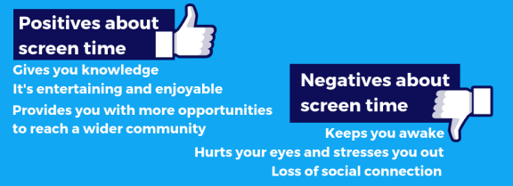

https://www.rcpch.ac.uk/sites/default/files/2018-12/rcpch_screen_time_guide_-_final.pdf

# Positive impact of a screen time

1. Screen time is good when technology is used as a tool
2. Screen time leads to writing more
3. Screen time helps your child learn discernment
4. Screen time helps families set boundaries
5. Screen time is educational
6. Screen time can lead to responsible children

https://literateforlife.org/screen-time-benefits/

**15.Design Thinking & User Experience**

Your research , options investigated, comparisons and context that make these relevant, how they will be applied.

1. **Design Planning Techniques(Low – High Fidelity)**

# Design Planning Techniques (Low – High Fidelity prototypes)

As a fourth stage of design thinking process **prototype** is one of the most important stages, especially because user or customer is finally involved. At this stage customer will receive some idea or rough model of what it’s going to look like, at this stage customer can add some requirements and specifications.

A **prototype** is a draft version of a future product that can help to explore any ideas and describe a particular feature or the overall design concept to users. It is important to do this stage before any proper design developing started. There are two types of prototypes **high-fidelity** (fully functioning site/template with some functionality) and **low-fidelity** (usually paper drawings). <https://www.visual-paradigm.com/guide/ux-design/wireframe-vs-storyboard-vs-wireflow-vs-mockup-vs-prototyping/>

## **High-fidelity prototyping**

High-fidelity prototyping is an interactive representation of the future product in its closest similarity to the final design, including colors, details, and functionality”. The “high” refers to the level of fullness that allows to examine usability questions in detail and make conclusions about the user’s behavior. High-fidelity prototypes look very similar to the end product.

**Advantages of high-fidelity prototypes**

* More interaction for the user.
* Likeliness of a user to navigate and work through a product on themselves with not much help from a designer.
* The closer to the completion of the product, the clearer the designer sees the final product
* Stakeholders able to see final product, after revision they can finalize some aspects of design to be changed.

**Disadvantages of high-fidelity prototypes**

* Takes more time to produce
* User might go to deep into details and ask to many questions about some minor things, because product looks almost finish and very realistic.
* At this stage it is very hard for designers to take criticism and implement changes for their working prototype.

Both prototype methods are often applied on the same product, with low-fidelity prototypes at the start of project and high-fidelity prototypes towards the end when reviews and tests become more refined.

<https://blog.prototypr.io/high-fidelity-prototyping-what-when-why-and-how-f5bbde6a7fd4>

### Example of high-fidelity prototype.

Very good example of a high-fidelity prototype is Mockup. It is static design for representing a future product. Mockup is representation of an actual final screen, where wireframe shows only a structure. This design helps to make a final decision about color schemes or layout of elements, but at this stage it is still not clickable or interactive. It also helps to give the user a more realistic impression of a final product. Despite lack a functional part, mockup can provide a final look for a customer, sometimes that is all what they want to see.

<https://www.visual-paradigm.com/guide/ux-design/wireframe-vs-storyboard-vs-wireflow-vs-mockup-vs-prototyping/>

## Low-fidelity prototype

Low-fidelity prototype represent a kind of sketch or paper model of the future product. With this model the client can interact and start making their own adjustments, which will be installed in high-fidelity prototype.

**Advantages of low-fidelity prototypes**

* Fast
* Inexpensive
* Can be changed very quickly
* Disposable
* Helps the designer to see a whole overview of a future product
* anyone can make a low-fidelity prototype, even unexperienced person
* Fosters design thinking

**Disadvantages of low-fidelity prototypes**

* Not realistic
* Bad quality and accuracy prototypes may lack validity
* May not be applicable for some products
* Some help from a designer might be necessary when user is going to interact with a prototype

https://www.workshopper.com/post/design-thinking-phase-4-everything-you-need-to-know-about-prototyping

### Examples of low-fidelity prototypes:

### Sketching

Sketching is a low fidelity prototype method that can help to visualize at the very beginning of developing process. Can be done by pencil and paper. Wireframe and storyboarding are based on sketching.

### Storyboarding

A storyboard is a visual representation of the scenes, dialogs, action in a sequential specific order. It is a method used to imitate ideas, designs and concepts for websites usually by presenting a sequence of wireframes in a order which could be already developed in the earlier development stage.

Storyboards can help to get a visual overview of a product. This is especially useful when creating a game that might contains many steps. This is a very quick way to see what game will look like before prototype or test it. Storyboarding the interaction between game history and different gameplays is an easy way to unravel problem areas before they appear in the expensive development phase.

<https://www.visual-paradigm.com/guide/ux-design/wireframe-vs-storyboard-vs-wireflow-vs-mockup-vs-prototyping/>

### Storyboard for game

At the very beginning of storyboard is creating "cards" that would describe plot points and events. Each card might be a few lines of text, script, a scribbled-down idea, or a sketch of a scene or even just a picture.

To accomplish the best result in creating a storyboard card some tactics might be handy.

First tactic is to create cards that would describe plot and idea. For example:

* **Primary Event Cards**
* **Secondary Event Cards**
* **Gameplay Event Cards**
* **Bonus Cards**
* **Character, attributes (sword for example)**
* Bosses or battle stage

Second tactic is to organize the board. Once all the story cards are created, it's time to put them into order. It is very important to start from somewhere, even if order is wrong, it is very easy to fix it by just shifting the around until desired result is achieved. It can be dome in Chronological Order or State or Sequence Order.

Third tactic or step is **review** and **revise.** After some “playing” with a cards, putting them in different order it is important to step back and review what is accomplished so far. Some feedback on what have been accomplished is required.

<https://gamescrye.com/blog/how-to-storyboard-your-game/>

## Wireframe

A wireframe is a sketch design of the future system, which must be fulfilled before any design work is started. Through clearness and simplicity, it allows anyone to read and understand it easily. Wireframe shows information with not many details, but enough to see a full picture and visualize a future product. At this method scenario can be showed to a customer for a future specialization and list of requirements from a customer. Wireframe can be called a blueprint, as it defines structure, content and functionality.

Benefits of wireframing are**:**

* Wireframes are easy to draw. Can be completed by pencil and paper
* Usually, it is easy to understand wireframes
* Easy to modify.
* No coding needed.
* In-line annotations. Specification and annotations can be showed on sketches.

<https://www.visual-paradigm.com/guide/ux-design/wireframe-vs-storyboard-vs-wireflow-vs-mockup-vs-prototyping/>

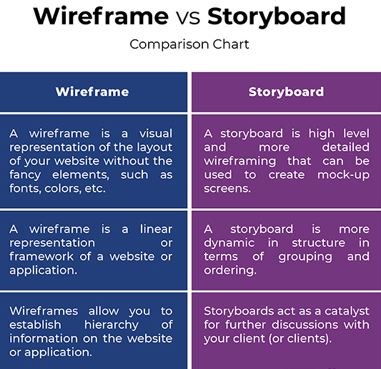

<http://www.differencebetween.net/technology/difference-between-wireframe-and-storyboard/#:~:text=A%20storyboard%20is%20quite%20similar,goes%20further%20inside%20the%20application>.

### Paper prototyping

Paper prototyping is a good way to create and test new designs in a short period of time. If paper prototype used correctly, it can provide maximum learning for minimum effort. Paper prototype a mix of techniques such as drawing, simulating, testing in according to create quickly “interface” for an user to interact with.

### Cons of Paper Prototyping.

* **User interaction at an early stage**
* **Cheap**
* **Encourages creativeness and imagination**
* **No design or coding skills required**
* **Minimum resources needed**
* **Fast evaluation and testing**
* **Assists in documentation**
* **Very popular in IT industry**

<https://usabilitygeek.com/paper-prototyping-as-a-usability-testing-technique/>

### Disadvantages of a paper prototypes.

* Might be hard to explain design.
* No testing online, only in person
* **Limited context and interaction**



<https://uxplanet.org/the-magic-of-paper-prototyping-51693eac6bc3>

### Summary

Wireframes and storyboards are verry similar, they basically follow the same pattern of navigation scheme and layout with no visual elements, thereby make life of web designers and web developers easier. Both wireframing and storyboarding are proposed techniques that are applied at very early stages as prerequisites in the web development process. However, storyboarding can be called - high level wireframing with better representation, sketches, layouts to share with the client to make sure that everybody is on the same page and work toward a goal. Wireframe and storyboard are playing one of the most crucial parts in UX deliverables of web development lifecycle.  
<http://www.differencebetween.net/technology/difference-between-wireframe-and-storyboard/#:~:text=A%20storyboard%20is%20quite%20similar,goes%20further%20inside%20the%20application>.

1. **Testing** 
   * **Usability**
   * **Functional**

Your research, options investigated, comparisons and context that make these relevant, how they will be applied.

1. **Audio**

# Audio

## Introduction

**Sound** is a type of energy generated by vibration. When an object vibrates, the surrounding air molecules move. These molecules collide with nearby molecules and cause them to vibrate as well. This causes them to encounter closer air molecules. This "chain reaction motion," known as a sound wave, continues until the molecule runs out of energy.

**Frequency**. If your ears are within the range of such vibrations, you will hear the sound. However, to hear the vibration, the vibration requires a certain speed. For example, you may not hear the slow vibrations that occur when you wave your hand in the air. The slowest vibration audible to the human ear is 20 vibrations per second. It will be a very low tone. The fastest vibration we can hear is 20,000 vibrations per second, which is very high-pitched. The frequency per second is called the frequency of the object and is measured in hertz (Hz).

**Pitch** is frequency related. Frequency is a scientific measure of pitch. The frequency is objective, but the pitch is completely subjective. The sound wave itself has no pitch. It is possible to measure their vibrations and give them frequencies, but the human brain needs to map them to their inherent pitch quality. The pitch of the sound is mainly determined by the mass (weight) of the vibrating object. In general, the heavier the mass, the slower the vibration and the lower the pitch. However, you can change the pitch by changing the tension or stiffness of the object. For example, a heavy E-string on an instrument may sound higher than a light E-string by tightening the tuning pegs to tension the strings.

When molecules vibrate in a medium, they can move back and forth or up and down. Sound energy causes molecules to move back and forth in the same direction that sound is propagating. This is called a longitudinal wave. (Shear waves occur when a molecule oscillates up and down perpendicular to the direction of wave propagation).

Speech (like hearing) is accompanied by vibration. When we speak, we move the air across the vocal cords, causing them to vibrate. Stretching these vocal cords changes the sound we make. Stretching the vocal cords produces high-pitched sounds and loosening them produces low-pitched sounds. This is called the pitch.

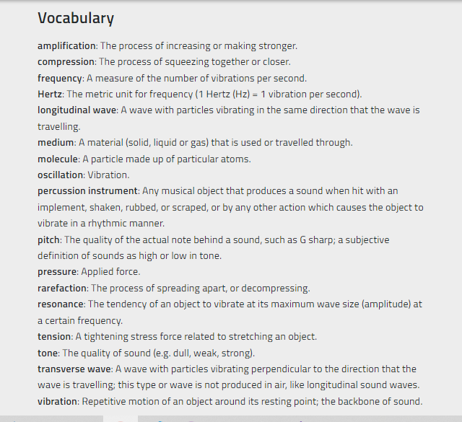

<https://www.scienceworld.ca/resource/sound/>

## Digital audio files

Digital audio files are formats for storing digital audio data on a computer system and digital representation of the sound that can heard on audio device. Audio files contain information about recordings such as voice, music, and even white noise. This information includes how the volume and pitch of these recorded sounds change, and the total recording time. The sound can be very quiet and high-pitched, like the bark of a cat, or loud and deep, like the roar of an explosion. As shown below, the frequency and amplitude of sound can also be visually represented by so-called waveforms.

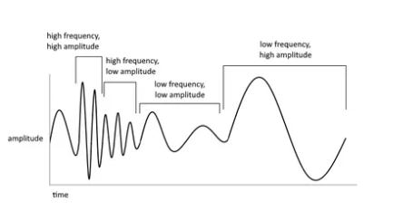

<https://www.omnicalculator.com/other/audio-file-size>

All audio files people are working with in the internet has to be stored somewhere. Depending on preferable format each of them displays the same information at different storage sizes or quality levels. In addition, some audio file formats contain metadata that provides information about the file or its contents.

## Lossless and lossy audio files

There are two main types of audio file—lossless file formats, and lossy file formats.

The difference between the two has to do with data compression.

Some methods of data compression make the file smaller, but still retain 100% of the information in the raw audio stream. These are known as **lossless** compression formats.

Other types of compression work by eliminating data in the audio that does not significantly affect the sound. These are called **lossy** compression formats because this method discards some information.

## **Uncompressed audio formats** digital audio workstation

There are other audio file formats that do not use data compression. These are called **uncompressed** audio formats. These file types act as containers for raw audio data without affecting size or quality. Uncompressed audio files are most commonly used for recording and mixing music in digital audio workstation. Nevertheless, there are also uncompressed audio files with different quality levels. These are based on the precision and precision with which analog audio signals are converted to digital. The higher the sample rate and bit depth used, the more information will be captured by the conversion process. Bit depth represents the accuracy of the AD / DA converter for measuring the amplitude or loudness level of the signal.

**Sample rate** means how many measurements are made per second. A higher sampling rate means that more individual measurements have been made. measured in hertz ([***Hz***](https://manual.audacityteam.org/man/glossary.html#hz)), or [***cycles***](https://manual.audacityteam.org/man/glossary.html#cycle) per second.

Some of the most common quality levels are listed below:

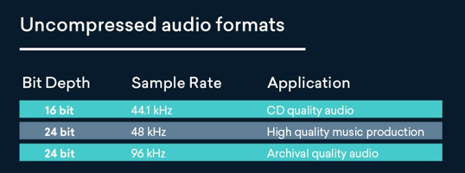

The most common formats of audio files

There are only few commonly world-wide used audio files.

Audio File Formats: How to Choose the Right File Type

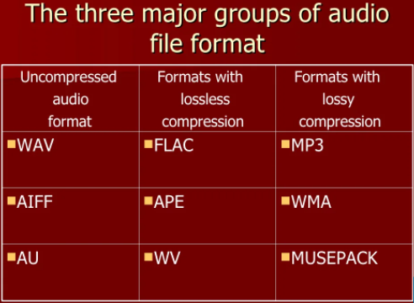

<https://pt.slideshare.net/lesleyw/audio-codec-presentation/5>

MP3

mp3 are the most common file type for general listening. MPEG-1 [Audio](https://www.collinsdictionary.com/dictionary/english/audio) Layer-3: [software](https://www.collinsdictionary.com/dictionary/english/software) that [enables](https://www.collinsdictionary.com/dictionary/english/enable) [files](https://www.collinsdictionary.com/dictionary/english/file) to be [compressed](https://www.collinsdictionary.com/dictionary/english/compress) quickly to 10% or less of their [original](https://www.collinsdictionary.com/dictionary/english/original) [size](https://www.collinsdictionary.com/dictionary/english/size) for [storage](https://www.collinsdictionary.com/dictionary/english/storage) on [disk](https://www.collinsdictionary.com/dictionary/english/disk) or [hard](https://www.collinsdictionary.com/dictionary/english/hard) [drive](https://www.collinsdictionary.com/dictionary/english/drive) or esp (electronic skip protection) for [transfer](https://www.collinsdictionary.com/dictionary/english/transfer) over the [internet](https://www.collinsdictionary.com/dictionary/english/internet)(https://www.collinsdictionary.com/dictionary/english/mp3).

AAC

An audio coding standard for lossy digital audio compression. Developed as a successor to the MP3 format, AAC typically delivers better sound quality than MP3 encoders at the same bit rate.

https://en.wikipedia.org/wiki/Advanced_Audio_Coding

AAC is a standard format for an Apple devices(iPod).

Ogg Vorbis

Newer open-source codec. It is of good quality, free to use and does not require a license fee. It's also an irreversible codec, but much more efficient than MP3s, especially at low data rates.

This format is alternative to lossy compressed formats like MP3. It’s notable for being the file type used for audio material on Wikipedia.

### FLAC

FLAC is an audio coding format for lossless compression of digital audio. This file format provides a bit-perfect copy of a CD, but at half the size. FLAC files make listening to lossless audio possible on devices with limited storage.

https://www.cnet.com/tech/home-entertainment/what-is-flac-the-high-def-mp3-explained/

### WAV

Waveform audio files (also known as WAV files) are one of the most popular digital audio formats and the “gold” standard for studio recording. WAV files are not compressed,the data is stored unchanged in its original format and does not require decoding.

AIFF

AIFF ([Audio Interchange File Format](https://en.wikipedia.org/wiki/Audio_Interchange_File_Format)) works almost the same way: Provides studio quality audio recording and playback. AIFF offers sample rate and bit depth options such as WAV files and registers audio waveforms in the PCM as accurate samples (slices) to provide the best possible audio recording quality and sound reproduction. Like WAV, AIFF stores data in uncompressed, lossless format. In other words, the quality is not compromised, only pure sound enjoyment is obtained.

## How to choose an audio file format

Simple guidelines for choosing an audio file format:

* Use uncompressed audio with high sample rate and bit depth (24-bit / 48kHz WAV or AIFF) for music production
* High bitrate compressed format (320 kbps MP3, AAC etc) - for general listening
* Lossless compressed format (FLAC) - for critical listening,

Tip: In the music production process, if the audio quality does not already exist, it cannot be restored. To get the highest quality files from LANDR mastering, you need to start with high resolution files. It is recommended that you set your DAW session to at least 24-bit / 44.1kHz, or higher if possible.

https://blog.landr.com/audio-file-formats/

## Codec

(**coder**-decoder or compression-decompression) A standard for compressing and decompressing digital media, especially audio and video. Codecs are used to save files to disk and transfer media over a computer network. Rapid compression and decompression of this data reduces bandwidth requirements and increases the amount of interactive and multimedia content accessed and transmitted over the network.

Different types of video are better encoded in different formats, just as some audio codecs better encode human voice and others better encode musical instrument music. In general, the most efficient codecs also require considerable processing power. Multimedia distribution always requires a balance between computing power and bandwidth.

https://www.britannica.com/technology/codec

Embedding audio in HTML documents

Inserting audio into a web page has never been easier, as web browsers did not have a consistent standard for defining embedded media files such as audio. Using HTML5 audio elements. The newly introduced HTML5 <audio > Element provides a standard way to embed audio in web pages. However, although the audio element is relatively new, it works with most modern web browsers

https://www.tutorialrepublic.com/html-tutorial/html5-audio.php

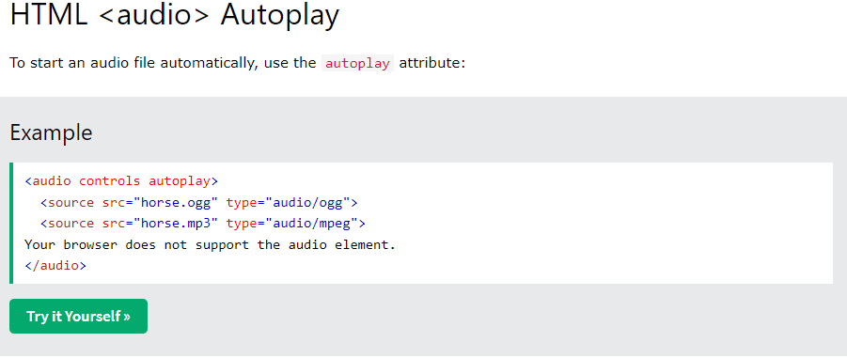

<https://www.w3schools.com/html/html5_audio.asp>

## Audio in Unity

**Audio Listener**: Think of an audio listener as an element of a game that listens to music. Basically, this is part of the world that captures the sounds created in the game. For example, as a character passes through a portal, the portal may emit a gentle “hum” or electrical noise. Something in the game needs to hear these sounds. In most cases, game developers add audio listeners to their cameras. This is because in most games the camera tracks the character, so the emitted sound is picked up and registered by a camera that shares the player's point of view. Therefore, all game sounds appear to surround the character from the correct position in 3D space.

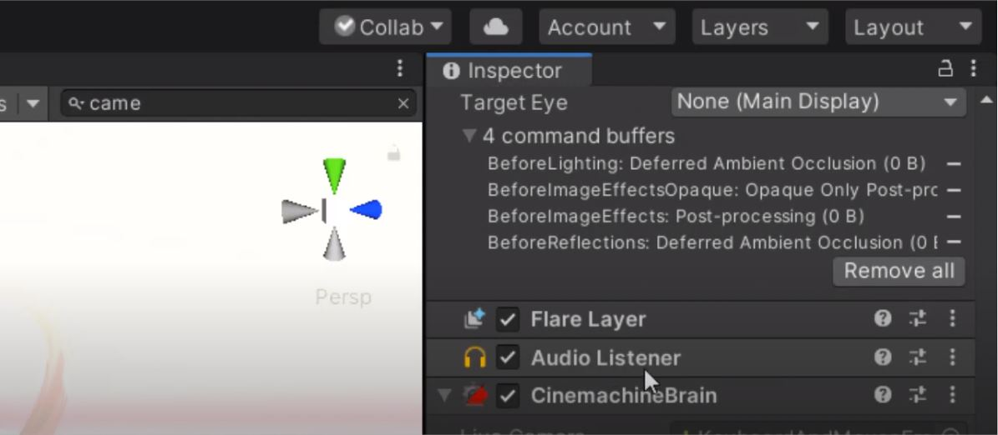

<https://www.sovereignmoon.studio/how-to-add-music-to-unity-3d-game-kit/>

**Creating Audio Sources.** The audio source is not going to work without the associated audio clip. Clips are the sound files that are actually perform. A source is like a controller that starts and stops playing that clip and changes other audio properties. TO be able to create a new audio source: 1. Import the audio file into Unity project. These are now audio clips. 2. From the menu bar, choose Game Object > Create Empty. 3. With the new Game Object selected, select Components > Audio > Audio Sources. 4. By using Inspector panel on the right side, choose the Audio Clip property on the Audio Source Component and assign a clip, either by dragging one from the Project Window or by clicking the small circle icon to the right of the Inspector property, then selecting a clip from the list. Note: If you only want to create an audio source for just one audio clip in your Assets folder, just drag that clip into the scene view. 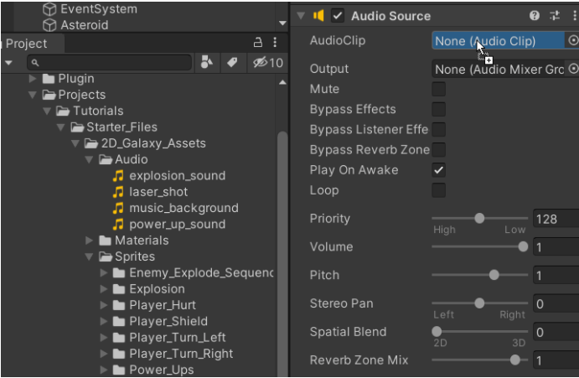

A Game Object with an audio source component is automatically created. When you drag a clip onto an existing Game Object, the clip will be attached with a new audio source (if it doesn't already exist). If the object already has an audio source, the newly dragged clip will replace the clip currently in use by the source.

<https://docs.unity3d.com/2019.3/Documentation/Manual/class-AudioSource.html>

1. **Text**

# Set of rules that help you improve readability and legibility of your text content.

According to (author) Communication plays an important role in design. It's important to create a clear connection between your website and your users so they can reach their goals. When we talk about communication in the context of web design, we usually mean text. Typography plays an important role in this. Around 95% percent of all information on the web source is in the form of written language.

There are few rules that highly recommended to be followed to gain the best result in readability and legibility of text content.

1. Avoid using different types of fonts. Reduce them to a max 3 fonts per project.
2. Use a classic (typical) font that all web browsers are supports.

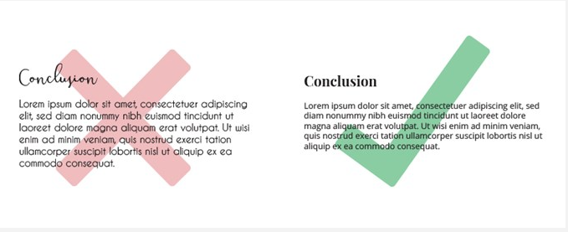

https://www.instantprint.co.uk/printspiration/print-design-tips/what-makes-a-bad-font-choice

1. Keep a line length at right number for better readability. For example, limit for a mobile device is 30-40 characters per.
2. Use fonts with observable different in letters to avoid confusion (for example “i”s and “l”s).
3. Do not use CAPS ALL caps text —acceptable for a logo or game menu, for example.
4. Keep acceptable space between lines. If the space is too small, it will be hard to read.

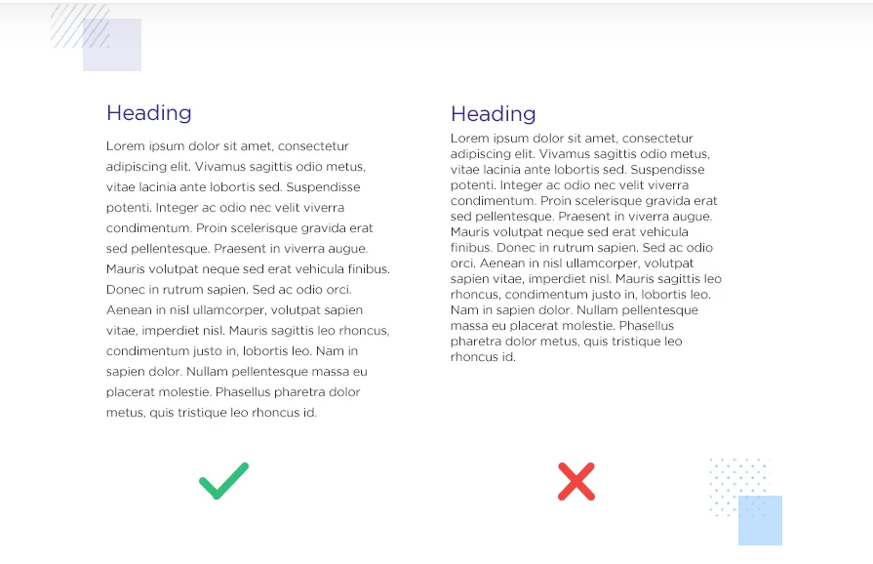

https://www.justinmind.com/blog/white-space-design/

1. Make the text more visible by adding a sufficient color
2. Do not mix green and red colors in a text and background, because color blind people will not be able to read it.
3. Try not to use blinking text. Flashes and flickers can trigger seizures. Also there is a chance that it will annoy an user.

<https://uxplanet.org/10-tips-on-typography-in-web-design-13a378f4aa0d>

Text design from an HTML (the standard markup language for documents designed to be displayed in a web browser) perspective.

**HTML** is the standard markup language for documents designed to be displayed in a web browser.

In designing text for web page, app or game, it is necessary to consider text from the designer's point of view. All information must be readable and easy to read while well suited to website styles. However, it is necessary to consider and work with the content hierarchy. Creating hierarchies are "big pictures" in the website configuration. However, if typography is applied then hierarchy must be created in an association with a specific text on the page. This will create relationships with their headers and work creates relationships with their headers and visually separate content and text.

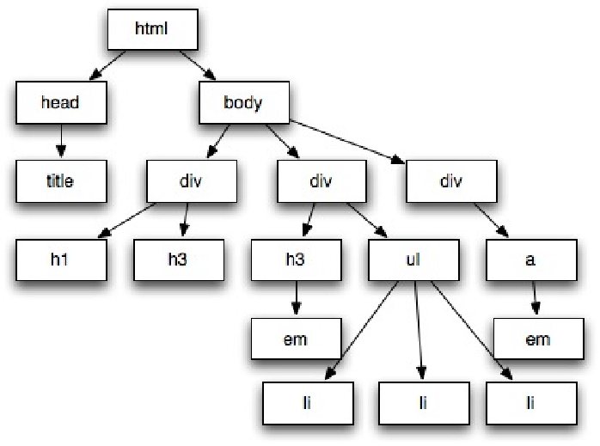

https://www.researchgate.net/figure/HTML-document-tree-representation_fig4_261313983

**Headings and Spacing.** Web content usually focuses on only several different text elements. Headlines are from H1-H6, but most websites use only H1-H4.

The space between texts is important to help you define page content itself. When the user finds a new header, it is checked if the content has been changed to a new theme or in an existing subject.

The negative storage space between text indicates how the contents of the page are relevant. Headers with many spaces are considered dominant, and headers are close to contextual paragraphs. The lower margin after the paragraph indicates the text line and the location where they belong to the hierarchy. Everything is related to the suppression of content hierarchies to visually distinguish the text on the page.

**Heading relationship**. Each heading reflects its own style, but style needs to be relevant to a whole style idea. Each internal block uses smaller sub header text. The amount of space between the header and the paragraph defines which paragraph belongs to which paragraph. Similarly, designer should apply enough space between smaller headers and larger headers. The negative space defines both visual design and typography hierarchies.

Rules for a successful heading style:

* The visual hierarchy should be evident by using space, size, color and/or text style. This should be visible even if you are standing 3-5 feet away from the monitor
* First child paragraph and each subheader should be close to each other’s.
* Place meaningful headings in close meaning to the project or situation to get the point across faster and more clearly.

<https://designshack.net/articles/layouts/web-design-best-practices-minimalism-typography/>

## Game Text

Size of a text for a game according to Stevens (takoqno) recommendation are a minimum of 28 pixels tall by three pixels wide when viewed on a 1080p screen. Might be a good idea to give the player the option to change the text size. Subtitles are probably the only text that should be an upper limit. Do not add captions that cover the entire screen. Players need to be able to resize text and subtitles. The default setting should be a large sans serif font.

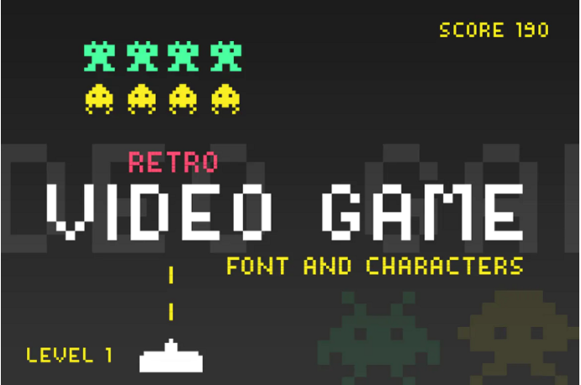

https://www.designbombs.com/best-gaming-fonts/

**Contrast note**

in the article (такойто ) also recommended a contrast ratio of 4.5: 1. This will provide enough contrast between the text and the background, making the text stand out and most likely to display the text in the player.

Deque Color Contrast Analyzer is highly recommended to check a contract between background color and text color (https://dequeuniversity.com/color-contrast)

Font suggestions: developers should use sans-serif fonts, that is, non-prosperous fonts at the end of each character, to maximize readability. These should be used not only for all menus, but also for all other forms of in-game communication so that players can analyze all the text they encounter. Most recommended fonts such as Arial, Helvetica, Verdana, and Comic Sans (suitable for dyslexics).

Using serif font for a game developing is a bad practice.

<https://www.gamesindustry.biz/articles/2020-08-05-a-quick-guide-to-readable-game-text>

To provide the best user experience in any form of interactive media it is very important to choose right Topography, including font size, colors, and font-styles. Below is an analysis of some aspects of the topography

# Analysis for a text design choice for a Menu

## Font style

|  |  |  |  |  |
| --- | --- | --- | --- | --- |
|  | Arial | Verdana | Curlz MT | Brush Script MT |
| sample | New Game | New Game | New Game | New Game |
| independent user rating | Good | Good | Too fancy,bad | Bad |

## Font size for a Menu

|  |  |  |  |  |
| --- | --- | --- | --- | --- |
|  | 6 | 14 | 20 | 72 |
| sample | New Game | New Game | New Game | New Game |
| independent user rating | Too small.  Bad | Might be too small.  Bad | Might be ok.  Ok | Probably good if compared to existing screen. Good |

## Text color contrast for menu (dark background)

|  |  |  |  |  |
| --- | --- | --- | --- | --- |
|  | Yellow | Blue | White | Red |
| sample | New Game | New Game | New Game | New Game |
| independent user rating | Good | Ok | Good | Might be bad for Color blind people |

## White space

|  |  |  |  |  |
| --- | --- | --- | --- | --- |
|  | Expanded 4pt | Normal | Condensed 1.2pt | Expanded 2pt |
| sample | New Game Congratulations | New Game Congratulations | New Game Congratulations | New Game Congratulations |
| independent user rating | Too big, almost the same size as a space between words | Ok | “To crowded” | Good |

Conclusion:Font-style:

1. **Animation and Video**

Your research , options investigated, comparisons and context that make these relevant, how they will be applied, including media examples

1. **Graphics and Images**

**Graphic and Image**

A **graphic** or graphic image is a digital representation of information other than text. B. Drawings, figures, or photographs. Many websites apply colorful graphic designs and images to convey their message. Two of the more common graphic formats that exist on the web are JPEG and GIF.

Computer graphics are either 2D or 3D. Early computers only supported monochrome 2D graphics. It was black and white (or black and white on some monitors). Eventually, computers began to support color images. Initial machines only supported 16 or 256 colors, but most computers today can display millions of colors of graphics. https://techterms.com/definition/graphics#:~:text=A%20graphic%20is%20an%20image,and%20letters%2C%20rather%20than%20images.

**Image**

An image, also known as a still image, is a digital image that is a binary representation of all types of visual information, such as drawings, individual video frames, logos, images, and graphics

<https://anydifferencebetween.com/difference-between-graphics-and-images/>

An image is made up of a rectangular array of dots called pixels. Image dimensions are specified in width X height, in pixels. The physical size of the image, in centimetres or inches, it totally depends on the resolution of the screen on which the image is displayed. Resolution is often measured in Dots Per Inch (DPI). An image will be smaller on a higher resolution device than on a lower resolution device. For color images, to represent all colors of an image there should be enough bits per pixel. The number of bits per pixel is called the image depth. [**https://www.tutorialspoint.com/multimedia/multimedia_images_graphics.htm**](https://www.tutorialspoint.com/multimedia/multimedia_images_graphics.htm)

**Codec** is a technology for compression files, consists of two components encoder **–** to compress files and decoder to decompress.

There are different types of image codecs available, based on different algorithm of compression with a different specification, platform etc.

**BMP.** Shrink image by throwing away pixels, which might lead to the change of an image in an unacceptable manner. Bitmap files are limited to RGB-images but provide very good photo quality. It’s not supported enough across multiple platforms.

**GIF**. Compresses by scanning horizontally across a row of pixels and finding solid areas of color with no loss of information for an image. Best choice for distributing color image on web. Allows to create animated graphics.

**JPEG.** Very low level of complexity, memory efficient, allows to reduce the file size. Provide a good quality picture. But codec has no lossless capability, provides only single quality and single resolution.

**MJPEG.** It is a lossy codec, often used as a storage format. Degradation of an image is minimal if image had 100% quality. Might be hard to work with a large image.

**TIFF.** An uncompressed TIFF codec retains the best quality of a photographic image, making it ideal for digital masters.

It’s also lossless, can be compressed or decompressed. But unfortunately produce large file size.

**PNG**. Lossless compression with no color information loss, is recognized and supported on all platforms. But does not support animation and has a low quality

[**https://imagecodecs.wordpress.com/**](https://imagecodecs.wordpress.com/)

**Image data types**

To create an image a variety of techniques could be used for representing data - called data types, such as monochrome and color images. Monochrome images are created in a single color, and color images are created in multiple colors. Some data types of images are:

**1-bit images**. An image is a set of pixels. In 1-bit images, each pixel is stored as a single bit (0 or 1). A bit has only two states either on or off, white, or black, true or false. Also known as a binary image.

A 1-bit image with resolution 640*480 needs a storage space of 640*480 bits or 37.5KB.

The quality or clarity of 1-bit image is extremely low.

**8-bit gray level images**. Each pixel of 8-bit grey level image is by a one byte, each pixel can hold 2 in power of 8 = 256 values between 0 and 255. Every pixel shown as a brightness on a scale from 0 to 255, it means all pictures composed of gray shades only – monochromatic.

A 8-bit image with resolution 640 x 480 needs a storage space of 300KB.

**24-bit color images** - each pixel equal to 3 bytes often representing R-G-B (Red, Green and Blue). Each true color represented by 256 shades of RGB – it means there are 16777216 color variations.

Often 24-bit color images are stored with an extra byte to store an alpha value for special effect information (32 bits in total).

Main disadvantages of this type that images require large storage space.

[**https://www.tutorialspoint.com/multimedia/multimedia_images_graphics.htm**](https://www.tutorialspoint.com/multimedia/multimedia_images_graphics.htm)

**Image file formats**

Applying the right image formats can help to get the best performance for a particular need. For example, by using a correct format speed of loading a webpage can be increased, it is especially important with a low internet traffic.

The are 13 the most popular image formats that are widely used.

**JPEG** – very good for web images, printing, saving files to camera, picture sharing, great for projects on the web. But better not used it for text-focused images.

**PNG** – great for web images, text-focused images, logos, and high-resolution pictures. Can be edited with no loss for quality, saves an image with more colors on a transparent background when used on web. Not good for printing.

**BMP** –generally outdated format. It’s supported by all biggest browsers and image viewers.

**GIF** – perfect for simple animations. Very good for demonstrating tutorial steps. However, not suitable for images with rich colors.

**TIFF/TIF** – good for printing and scanning documents. Not suitable for web pages, takes forever to load. Because of lossless compression original image data is maintained regardless of how often you might copy, re-save, or compress the original file.

**HEIF** – it’s used for saving high-quality images on newer devices, providing better-optimized file sizes. It is not the best choice for accessing images on browsers and OS.

**RAW** – it is least-processed image type, recommended for high-quality photographs. RAW images are very important because they capture every element of a photo without processing and losing small visual details. Not suitable for web usage.

**PSD** – it is special Adobe Photoshop’s format used for graphic design projects that can be edited. This type of file contains "layers" that make modifying the image much easier to handle. Not suitable for printing or web usage.

**SVG** – great for web images, images with simple shapes, 2D illustrations, and importing 2D images to 3D modelling software. Not suitable for displaying detailed images with high color depth, such as photographs.

**EPS** – file in vector format, should be used for printing, illustrations, graphic design. Bad for photographs.

**PDF** – great for printing, visual reports, infographics. Not suitable if some changes are required to the image.

**INDD** – used in Adobe InDesign for saving editable layouts or page designs. Not suitable for web usage.

**AI** – mainly used for saving vector graphics in Adobe Illustrator. Most reliable type of file format for using images in all types of projects from web to print.

[**https://www.hostinger.com/tutorials/best-image-formats**](https://www.hostinger.com/tutorials/best-image-formats)

**Raster Image Files and Vector Image Files**

Raster images are constructed by a series of pixels, or individual blocks, to form an image. Every photo a raster image. Pixels have a defined proportion based on their resolution (high or low), and when the pixels are stretched to fill space, they were not originally supposed to fit, they become distorted, resulting in blurry or unclear images.

[**Top 8 Raster Formats**](https://www.hostinger.com/tutorials/best-image-formats#Top_8_Raster_Formats)

[1. JPEG and JPG](https://www.hostinger.com/tutorials/best-image-formats#1_JPEG_and_JPG)

[2. PNG](https://www.hostinger.com/tutorials/best-image-formats#2_PNG)

[3. BMP](https://www.hostinger.com/tutorials/best-image-formats#3_BMP)

[4. GIF](https://www.hostinger.com/tutorials/best-image-formats#4_GIF)

[5. TIFF](https://www.hostinger.com/tutorials/best-image-formats#5_TIFF)

[6. HEIF](https://www.hostinger.com/tutorials/best-image-formats#6_HEIF)

[7. RAW](https://www.hostinger.com/tutorials/best-image-formats#7_RAW)

[8. PSD](https://www.hostinger.com/tutorials/best-image-formats#8_PSD)

**Vector Image Files**

Vector images are way more flexible. They are constructed using proportional formulas rather than pixels. **EPS**, **AI** and **PDF** are perfect for creating graphics that require frequent resizing. Provide ability for images to be sized as tiny as a postage stamp, or huge enough to fit on an 18-wheeler.

[Top 5 Vector Formats](https://www.hostinger.com/tutorials/best-image-formats#Top_5_Vector_Formats)

[1. SVG](https://www.hostinger.com/tutorials/best-image-formats#1_SVG)

[2. EPS](https://www.hostinger.com/tutorials/best-image-formats#2_EPS)

[3. PDF](https://www.hostinger.com/tutorials/best-image-formats#3_PDF)

[4. INDD](https://www.hostinger.com/tutorials/best-image-formats#4_INDD)

[5. AI](https://www.hostinger.com/tutorials/best-image-formats#5_AI)

https://blog.hubspot.com/insiders/different-types-of-image-files

**Different Types of Media**

We use various media to get news, learn new things and have fun. With the development of technology, we can choose the type of media we want to use.

The goal of media is to convey an advertising message to the audience through the most appropriate media channel for their product.

In general, media can be classified in three mains.

**Print media.** Previously, this type of media was the only way to convey information to the population. In the 80s and 90s print media was the only means of entertainment. People trusted and on magazines, newspapers – good source of vital information about a country or the world. Includes newspaper, magazines, books, banners, billboards, brochures, flyers etc.

**Web media (internet media).** The most popular type of media at the moment, moreover some young generations are using only that type of media. This media includes social networks or websites, online forums, podcasts

**Online forums -** an online place where we can comment, message, or discuss a particular topic. Forums allow us to share knowledge with other people with the same interest. That’s why it’s regarded as the best platform to seek support and assistance.

[**https://whatagraph.com/blog/articles/different-types-of-media**](https://whatagraph.com/blog/articles/different-types-of-media)

## **Pixelate**

Most image files, such as JPG, PNG, and GIF, are bitmaps or they're maps of bits - essentially grids of pixels that blend smoothly together to form an image. Pixels are the smallest squares of hue, saturation, and lightness (HSL) that make up the grid of a digital image. Pixelation occurs when, instead of perfectly blending, pixels are visible to the naked eye. Image can be accidentally pixelate when change a scale of an image to a size too large for its resolution. https://www.adobe.com/nz/creativecloud/photography/discover/pixelate-image.html

**Free sources** of images for games can be found on the internet, some examples of those website are below:

<https://www.freepik.com/free-photos-vectors/2d-game>

<https://craftpix.net/freebies/>

There is a very good tool that can be used for pixelating any images

**PIXEL IT** <https://giventofly.github.io/pixelit/>

**Unity**

Unity imports image files as textures. Unity supports most common image file types, such as BMP, TIF, TGA, JPG, and PSD. If you save your layered Photoshop (.psd) files in your Assets folder, Unity imports them as flattened images. ( <https://docs.unity3d.com/Manual/AssetTypes.html#:~:text=Unity%20supports%20the%20FBX%20file,natively%20supports%20importing%20SketchUp%20files>.)

Analysis of the most common image extensions is below. Compressing and converting of the image was applied by using a GIMP. Image was taken from a free source. As a source for converting and compressing was taken the same original image every time.

|  |  |  |  |  |
| --- | --- | --- | --- | --- |
| Image extension | Image  compression | Dimensions | Image size | Review of an user |
| GIF | No compression applied | 3000*2132 | 1832kb | Bad, blurry |
| TIFF | Not applicable | 3000*2132 | 1875kb | Good |
| BMP | 16bit | 3000*2132 | 12493kb | Bad quality |
| BMP | 24bit | 3000*2132 | 18739kb | Ok |
| JPG | Low | 3000*2132 | 3175kb | Perfect |
| JPG | Medium | 3000*2132 | 550kb | Acceptable if no zooming is applied |
| JPG | High | 3000*2132 | 118kb | Terrible, blurry |
| JPG | Original as downloaded | 3000*2132 | 930kb | Good |
| PNG | Low | 3000*2132 | 18785kb | Perfect |
| PNG | High | 3000*2132 | 5559kb | Almost Perfect |

**Conclusion**

After the analysis, the highest rating was shown by the formats PNG and JPG. Even with no compression applied, JPG-format provided extremely good quality despite small image size – only 3 MB. Despite after full zooming in 460% applied image is still showing good quality. PNG extension on the other hand have an extremely large size of an image – 18 MB, but after compression down to 5.5MB quality is almost the same as before.

Lowest rating received by JPG format after maximum compression down to 118KB, unfortunately this image is awful at this size.

Gif format is also terrible choice for an image, because with a size of 1832KB quality is terrible as JPG with 118KB size.

**20.CONCLUSION**

**21.REFERENCES**